ARCHITECTURE & GUI STANDARD OF APPLICATION
- Architecture of Application

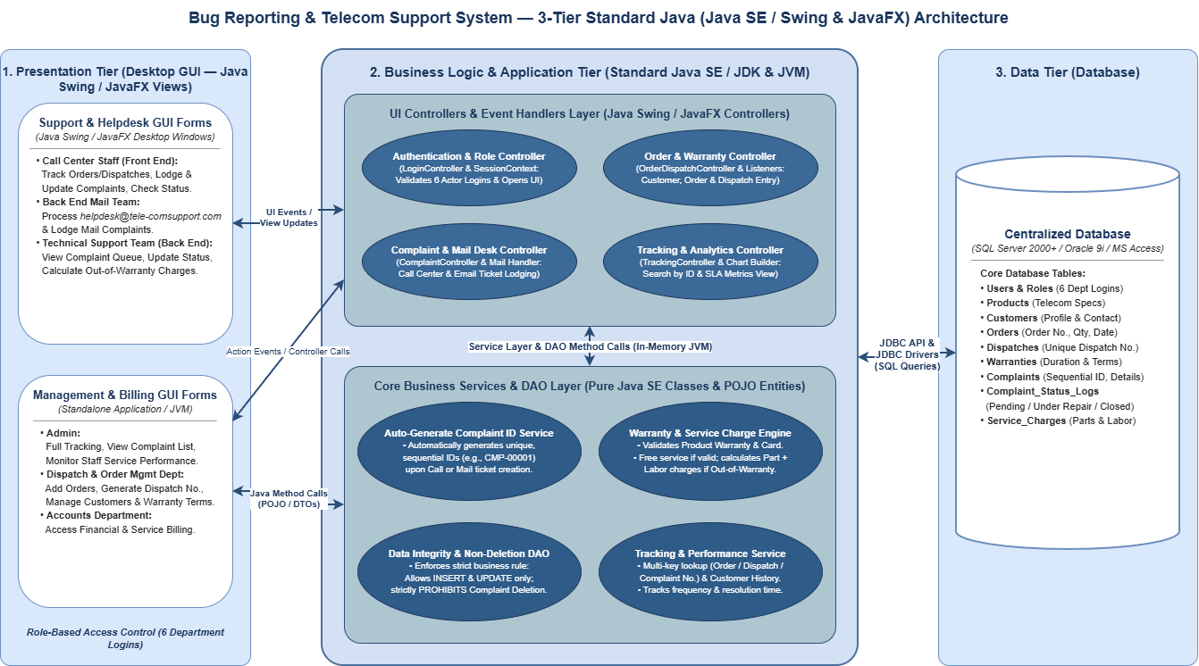
- GUI Standard Application

Property | Value
Document Theme and Color Scheme | Corporate Telecom Blue & Light Gray Theme
Form - Background Color | Light Gray / Alice Blue
Title - Font Size | 18pt (Main Form Title / Header) & 14pt (Sub-section Title)
Title - Font Color | Navy Blue
Title - Font Style | Bold, Sans-serif
Title - Alignment | Center Aligned / Left Aligned
Background color of Controls on the form | TextBox / ComboBox / DatePicker / DataGrid: White  Read-only / Auto-generated Fields: Light Silver  Primary Command Buttons: Royal Blue  Secondary / Reset / Cancel Buttons: Slate Gray
Foreground color of Controls on the form | Input Controls: Dark Charcoal / Black  Read-only Text: Muted Gray  Command Buttons Text: White  Validation / Error Messages: Crimson Red
Control Caption - Font Size | 10 pt (Standard Labels/Captions) & 9 pt (Helper text / Note)
Control Caption - Font Color | Dark Slate / Black
Control Caption - Font Style | Regular / Bold — Font: Segoe UI & Tahoma
Control caption and controls - Alignment | Control Captions (Labels): Left Aligned, Middle Vertically  Input Controls: Left Aligned (Name, Address, Fault Description); Right Aligned (Quantity, Service Charges); Center Aligned(Order ID, Dispatch No., Complaint ID, Date)
Command button - Alienment | Button location: (Bottom-Right or Bottom-Center Form/Panel)8px - 12px.  Button Text: Center Aligned (Min-Width: 100px, Height: 34px).  (Delete Button): (Disabled / Hidden)

